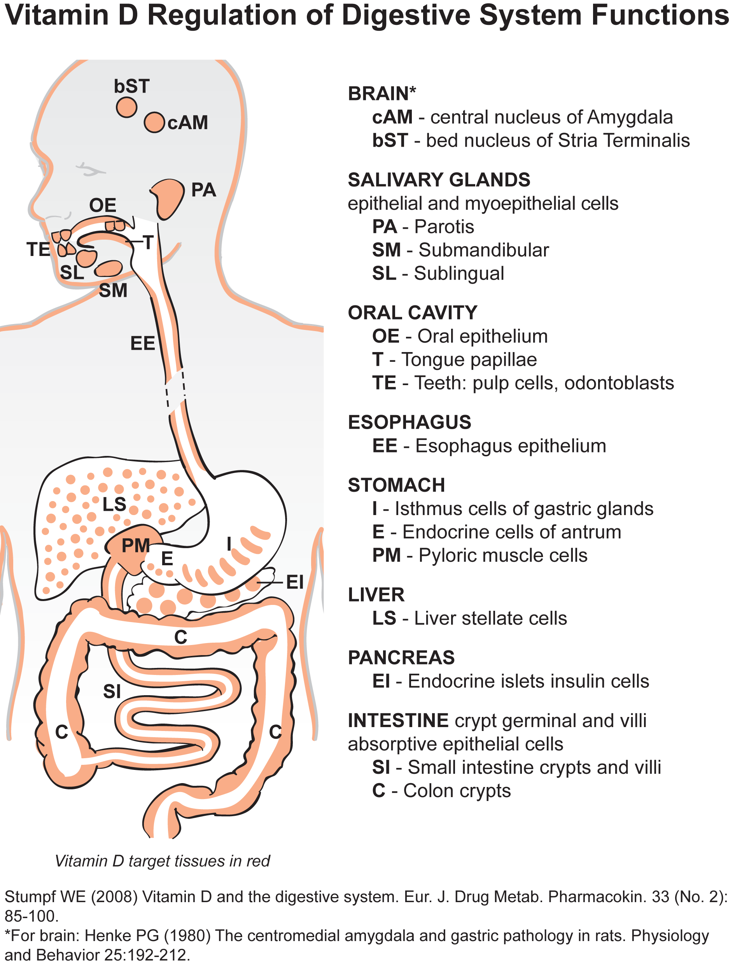

Stumpf WE (2008) Vitamin D and the digestive system. Eur J. Drug Metab. Pharmacokin. 33 (No. 2): 85-100.

\*Cechetto DF  (1987) Central representation of visceral function. Federation Proc. 46:17-23. [Nucleus of the septal stria terminalis, central amygdala, nucleus parabrachialis lateralis, others. Experimental data from stereotactic lesions, from ectrophysiology, and from histochemistry correspond to the nuclear localization of 3H-1,25(OH)2vitamin D3.]

\* Henke PG (1980) The centromedial amygdala and gastric pathology in rats. Physiology and Behavior 25:192-212.